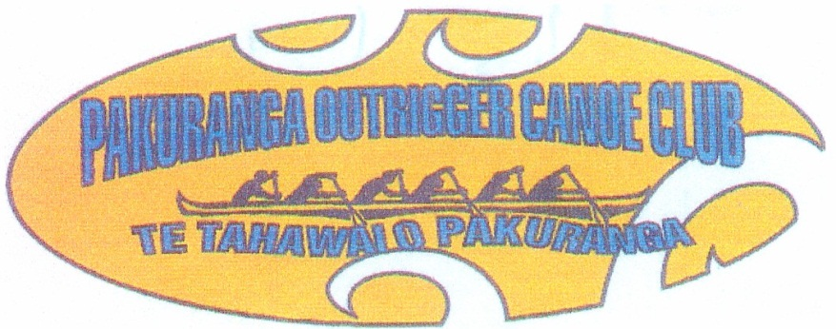

POCC are running a series of regattas with two races on each day. Being on the Estuary the conditions will be near on perfect, so the racing will be “Hard N Fast”. This is a great new way to get through the winter months and should prove both exciting and challenging. Registration will be open from 7am upstairs in Nga Hau Maiangi and there will be open access to showers for all paddlers after your race.
With reference to the “Covid19 Virus”
Please refrain from all un-necessary physical contact and please respect others personal space.

Programme
Saturday 17th July 2021
High Tide: 12.45pm
- 07.00am Race 1 Registration open
- 08.00 am Karakia
- 08.00 am Race 1 Briefing (5km) All W6 Divisions (including novice)
- 08.30am Race 1 start
- Hot Soup on return

- 07.00am Race 2 Registration open
- 09.30am Race 2 Briefing (10km) All W6 Divisions
- 10.00am Race 2 start
- Hot Soup on return
All registrations must be on-line at the NKOA (Waka Ama NZ) website.
All race fees must be paid on-line by participating Clubs: Acc 38-9018-0482221-02
REGISTRATIONS CLOSE Wednesday 14th July, 2021 11.59pm
There will be no registration on the day
Entry Fees: Race 1 Competitors $10.00, Race 2 Competitors $20.00

